**Faculty Profile Template**

1. **Basic Information**

* **Name**: Akshay Kumar Sahu
* **Designation**: Assistant Professor
* **Department/School**: Mechanical Engineering
* **Institution Name**: SSIPMT Raipur
* **Email ID**: akshay.sahu@ssipmt.com
* **Contact Number**: 8435420098
* **Photograph**: *(Passport-size, professional)*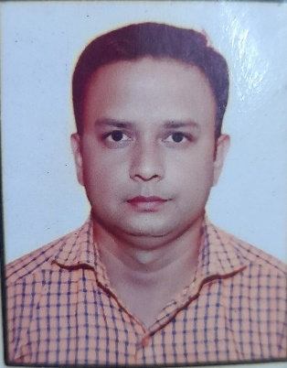

1. **Educational Qualifications**

|  |  |  |  |
| --- | --- | --- | --- |
| **Degree** | **Specialization** | **Institution** | **Year of Completion** |
| UG | Mechanical Engineering | GEC Jagdalpur | 2011 |
| PG | Thermal Engineering | GEC Jagdalpur | 2014 |
| Ph.D. |  |  |  |
| Others | *(if applicable)* |  |  |

1. **Teaching & Research Experience**

* **Total Teaching Experience**: 6 years
* **Industry Experience**: *(if any)*
* **Research Experience**:

1. **Courses Taught**

* List of key UG/PG courses taught: Engineering Mechanics, Fluid Mechanics, Mechanics of Solids part 1 and part 2, Mechanical Measurements and Metrology, Fluid Machines, IC Engines, Refrigeration and Air conditioning

1. **Research Interests / Specialization**

* Waste heat recovery system, Micro machining

1. **Publications (Last 5 Years)**

* Journals (APA/IEEE format)
* Conference Proceedings
* Book Chapters / Books Authored

1. **Research Guidance**

|  |  |  |
| --- | --- | --- |
| **Level** | **Awarded** | **Ongoing** |
| Ph.D. |  |  |
| PG |  |  |

1. **Awards & Recognitions**

* Institutional / National / International

1. **Administrative Roles**

* Positions held (e.g., HoD, IQAC Coordinator, NAAC/NBA Committee Member)

1. **Professional Memberships**

* e.g., ISTE, IEEE, INFLIBNET, etc.

1. **Web Presence**

* Personal academic webpage / Google Scholar / ResearchGate / ORCID